SANTFA invites you to view a concept demonstration of Aqua-Till:
Possibilities for ultra high-pressure water cutters in sustainable agriculture.

Aqua-Till is a SANTFA-led invention, which uses ultra-high pressure (55,000 psi) water cutters.

It is currently being trialed for its potential to cut stubble, inject fertilizer and slash weeds.
9:30am – 10:30am
Tuesday 9th of April 2013 – Free Entry
Small paddock next to Wickham Flower, Bordertown

SANTFA’s Research & Development Manager, Greg Butler will lead the demonstration and
field questions from the audience.

Proudly supported by the Federal Government’s Caring for Our Country Investment Program.

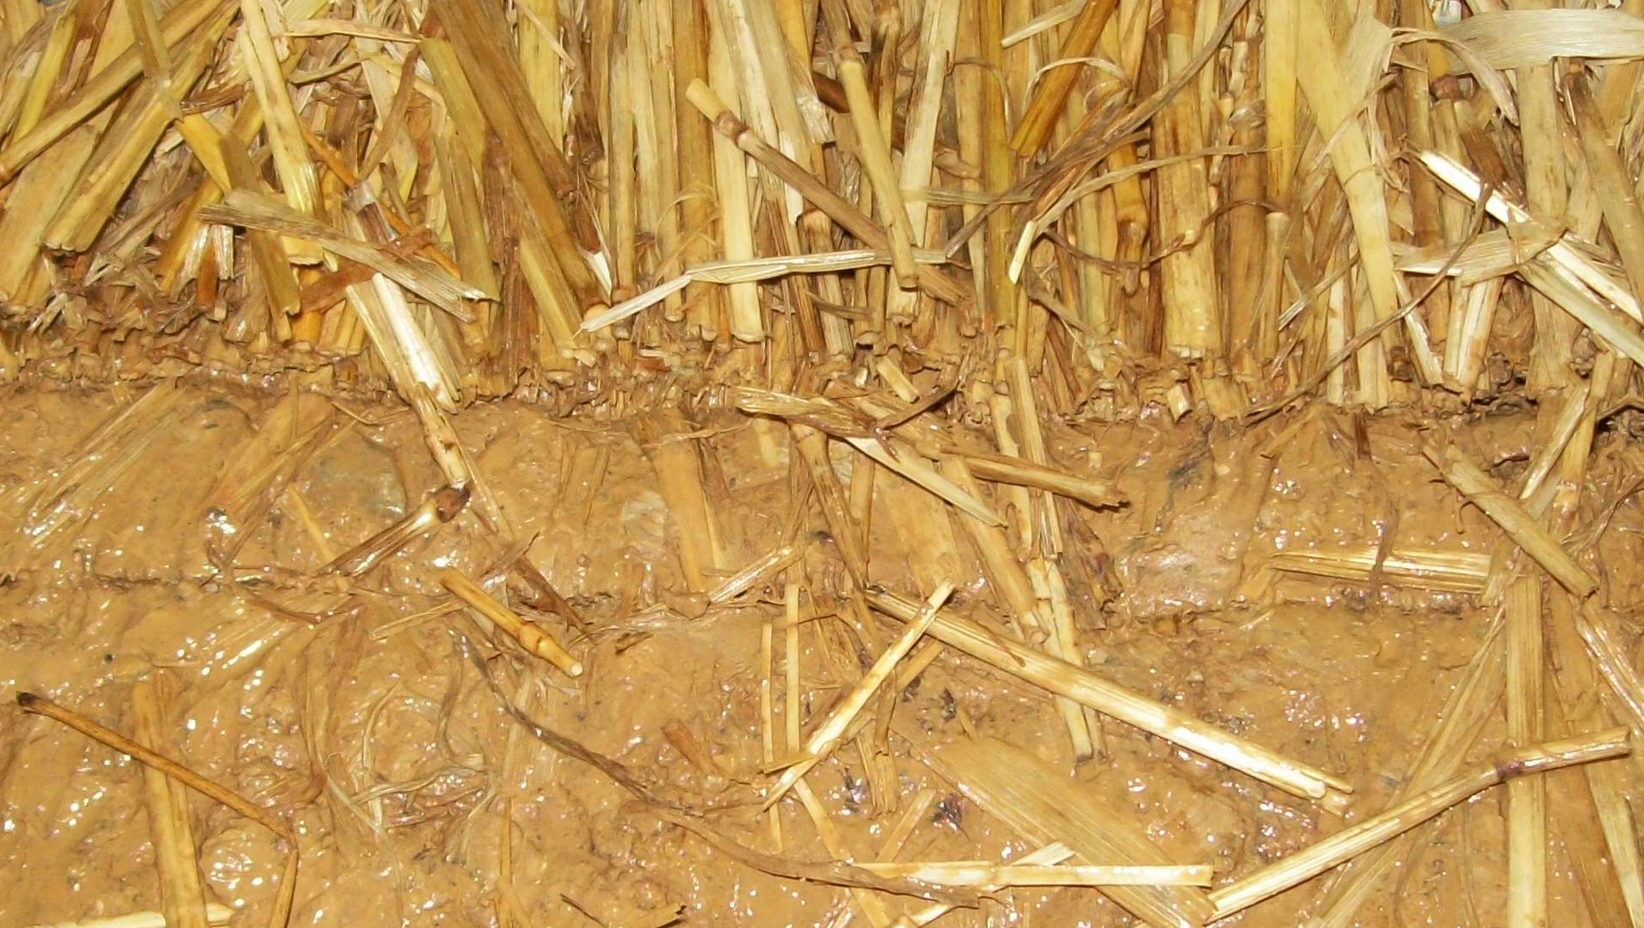
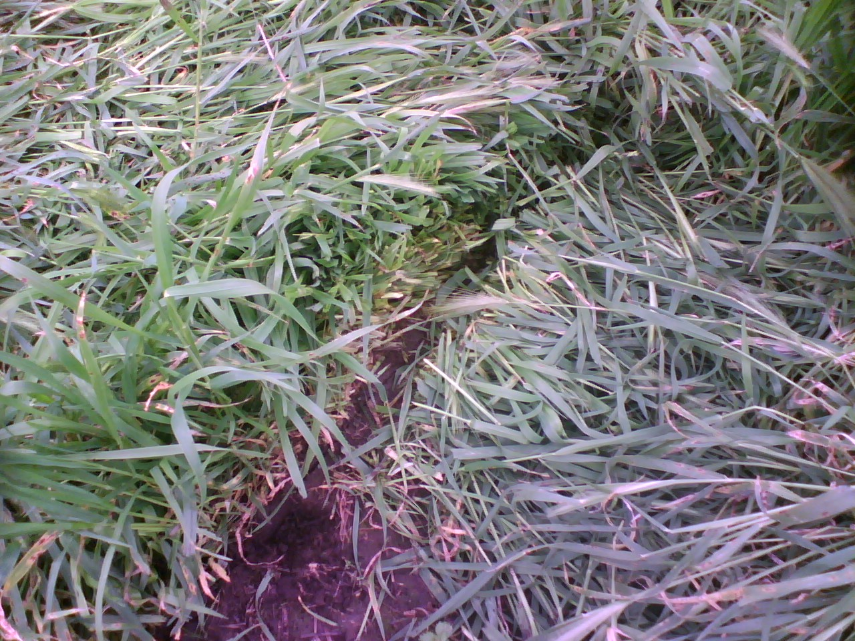
For further information:
Greg Butler
0427 242 278
greg@santfa.com.au
www.santfa.com.au

